

2023

Vol.
4
, Issue 1

ASRIC JOURNAL ON HEALTH SCIENCES

Vol. 4, Issue 1 2023



Copyright © African Scientific Research and Innovation Council, 2023
Published by: African Scientific Research and Innovation Council
Plot 114 Yakubu Gowon Crescent Asokoro
Abuja, Nigeria

asric_editor@yahoo.com
www.asric.africa

ISSN 2795-3580 (online) 2795-3637 (print)

The views expressed in the ASRIC Scientific Journals are those of the authors and not necessarily those of the African Scientific Research and Innovation Council; the African Union Scientific, Technical and Research Commission; or the organisations that they belong to.

EDITORIAL BOARD

Editor in Chief:

Dr Hany Sleem  Editorial Board: | National Hepatology and Tropical Medicine Research Institute (NHTMRI), Cairo, Egypt; hanysleem@hotmail.com
Prof. Mimmie Claudine Watts | Federation University, Australia; m.labeautenoire@gmail.com
Prof. Gabriel Magoma | Pan African University Institute for Science Technology and Innovation (PAUSTI), Kenya; gmagoma2000@yahoo.com; gmagoma2000@gmail.com
Dr Matthew Allsop | School of Medicine, University of Leeds, UK; M.J.Allsop@leeds.ac.uk

The editorial correspondence should be sent to:
Editor-in-Chief, ASRIC Scientific Journals,
African Scientific Research and Innovation Council,
Plot 114 Yakubu Gowon Crescent Asokoro
Abuja, Nigeria

Table of Contents
Effect of Food Availability Variation on Dietary Consumption and Nutritional Adequacy of Reproductive-Age Women Benefiting from a Multisectoral Intervention: A Longitudinal Study in Benin Nagassi Whomou Jacob Victor, Fanou-Fogny Nadia,
Mitchikpè Comlan Evariste Simon 1
Factors Associated with Joint Decision on Contraceptive Use Among Currently
Married Women In Nigeria: Evidence From Repeated Cross-Sectional, Nationally
Representative Data Matthew A. Alabi, Motunrayo I. Fasasi , Osayekemwen Ojo-Ebenezer
................................................................................................................................................ 14
Moleculer Detection and Characterisation of Bordetella Pertusis and Presence of Pertactin Gene Among Patients with Symptoms of Respiratory Tract Infection in
Kaduna State Astaharam Ardo Jabbo, Maryam Ibrahim Rimi, Muhammad Sani Abdulsalam,
Ahmad Babangida Suleiman, Mohammed Bello Yerima ...................................................... 24
Serum Proteogenomic Investigation of C-X-C Motif Chemokine 10 (CXCL10) and Zika Virus RNA in Pregnant Women of Nigerian Tertiary Teaching Hospitals Hafeez
Aderinsayo Adekola, David Ajiboye Ojo, Saka Adebayo Balogun, Morenike Atinuke Dipeolu
................................................................................................................................................ 37
In vitro Antibacterial Activities and Molecular Analysis of Bacillus species from Garden Soil against selected Pathogens Ismail Babatunde Onajobi¹, Effiong Emmanuel Okon,
Oyindamola John Samson, Sulaimon Adebisi Aina, Jamiu Oluwatosin Adeyemi, Hafeez
Aderinsayo Adekola, Titilayo Omolade Abiona .................................................................... 52
Antimicrobial Evaluation of Microencapsulated Ciprofloxacin+Irvinga Gabonensis
Gum against Klebsiella Species from Patients in a Teaching Hospital in Benin Nathaniel
E. Onyenwe, Nnabuike D. Nnamani, Chioma N. Nwafor, Victor O. Onojob Samuel O. Alabi,
Obun-Nnadi Charity, Omolara O. Adeboye ........................................................................... 63
A Novel Co-Processed Excipient with Enhanced Direct Compression Functionality for
Improved Diluent Performance in Ibuprofen Tablets Mohammed Blessing Boma, Tijjani
Sambo Fatima, Yahaya, Zwanden Sule, Mallam Danjuma .................................................... 77

ASRIC JOURNAL ON HEALTH SCIENCES


Available online at www.asric.org
ASRIC Journal on Health Sciences Vol.4(1)(2023) 63-76

Antimicrobial Evaluation of Microencapsulated Ciprofloxacin+Irvinga
Gabonensis Gum against Klebsiella species from Patients in a Teaching

Hospital in Benin

Nathaniel E. Onyenwe^{1*}, Nnabuike D. Nnamani², Chioma N. Nwafor³, Victor O. Onojob¹

Samuel O. Alabi ⁴, Obum-Nnadi Charity ⁵, Omolara O. Adeboye⁶

1Department of Pharmaceutical Microbiology, College of Pharmacy, Igbinedion University Okada, Edo State, Nigeria
²Department of Pharmaceutics and Pharmacy Technology, College of Pharmacy, Igbinedion University Okada,Edo State, Nigeria
³Department of applied microbiology and brewing Nnamdi Azikiwe University Awka Nigeria ⁴Department of Pharmaceutical Microbiology, Faculty of Pharmacy, University of Ibadan, Oyo State, Nigeria.
⁵Department of Medical Microbiology, Veritas University, Abuja
⁶Department of Chemistry, Emmanuel Alayande University of Education, P.M.B 1010, Oyo, Nigeria.

*Corresponding author: onyenwe.ejikeme@iuokada.edu.ng

Abstract
Klebsiella species causes nosocomial infections and other diseases. The use of Ciprofloxacin formulations has been adopted for skin and systemic infections, hence Irvingia gabonensis a specie of African trees in the genus Irvingia, was used for the microencapsulation of ciprofloxacin and used against sequenced disease causing Klebsiella species. Adopting the non-solvent addition of microencapsulation, drug-excipient compatibility test, batches of encapsulated ciprofloxacin + Irvinga gabonenesis, gelatin gum with the pure active ciprofloxacin were prepared from formula X. The FT-IR absorbance at different wavelength was recorded. The resultant microncapsulated drugs were screened for antimicrobial activity using the single disc agar diffusion against K. quasipneumoniae, K. aerogenes, and K. pneumoniae isolates. There were no difference in wavelength of FT-IR spectra of Irvinga gabonensis, pure active ciprofloxacin, and ciprofloxacin blend+Irvinga gabonensis gum. The pure active ciprofloxacin was very effective at the concentration of 8.3µg/mL(IC₅₀:1.02µg/ml) and 4.15(IC₅₀:0.08µg/ml) against all the Klebsiella species. The ciprofloxacin + Irvinga gabonenesis at 7.12 µg/mL (IC₅₀:0.90µg/mL) had significant zone of inhibition when compared to the pure active ciprofloxacin drug alone (IC₅₀:0.80µg/mL) at a concentration of 4.12µg/ml active ciprofloxacin. Based on the 95% mean inhibition concentration, ciprofloxacin + Irvinga gabonenesis gum (IC₅₀:0.90µg/mL) is a better excipient than ciprofloxacin + Gelatin gum (IC₅₀:1.38µg/mL). Ciprofloxacin + Irvinga gabonensis gum exerts effective antimicrobial activities and compactibility in terms of effective drug release.
Keywords: Antimicrobial; Irvinga gabonensis, Ciprofloxacin, microencapsulation, sequencing

Introduction
Klebsiella pneumoniae is one of the organisms that causes nosocomial infections and other diseases including infection of the urinary tract, respiratory system, wounds and the blood stream (Struve, and Krogfelt,2004; Varon and Alangaden,2004). Klebsiella pneumoniae is a rare cause of community-acquired pneumonia but accounts for a higher proportion of pneumonia acquired in hospitals (Bryan and Nicholson,2011), where patients are more likely to be treated with antibiotics which has led to this bacterium dominating the pharyngeal flora (Bryan and Nicholson,2011). K. pneumoniae inhabits several cavities, more especially the oral cavity of those with poor dental hygiene, which leads to increase in the risk of contracting Klebsiella pneumonia infections (Bryan and Nicholson,2011).The emergence of multidrug-resistant species of K. pneumoniae has increased recently in the world, according to Pakzad, et al.,(2013), and Klebsiella spp. have been found to harbor AcrAB efflux system as one of the principal mechanism which is responsible for the resistance to fluoroquinolones (Pakzad, et al.,2013). Based on this facts there has been difficulty in the treatment of patients infected with multidrug resistant strains (MDR) of K. pneumoniae by using antimicrobial agents which has caused a shift in the mechanism of fluoroquinolone functions as regards to usage, especially the ciprofloxacin according to Pakzad, et al.,(2013).
Ciprofloxacin is the most frequently prescribed fluoroquinolone for urinary tract infections and pneumonia, because of its availability in oral (tablet and suspension) and intravenous formulations (Malele1 et. al.,2014). It is a second-generation fluoroquinolone that has spawned many derivative antibiotics (Zhang, et al., 2018). This drug has been formulated for immediate use as release tablets, oral suspensions, and intravenous injections, which is intended for use or indicated for the treatment of lower respiratory tract infections including acute exacerbations of chronic bronchitis, urinary tract infections, complicated urinary tract infections in pediatrics, complicated pyelonephritis in pediatrics, and acute sinusitis (Varshney, et. al.,2014). Generally, ciprofloxacin is well known drug used against reference bacterial strains like those employed in this study. Though resistance to fluoroquinolones has recently increased among bacterial strains isolated from outpatients in several hospitals (Pakzad, et al.,2013), it has not been clearly proven in this part of Nigeria, where a plant material like Irvingia gabonensis gum is microencapsulated with ciprofloxacin and dissolved into solution.
Micro-encapsulation has been described as the study of tiny particles or droplets which are surrounded by a coating to give small capsules (Jyothi, et.al.,2012). Also, it can be simply put as a microcapsule in a small sphere with a uniform wall around it, while the material inside the microcapsule is known as the core, internal phase, or fill, whereas the wall is sometimes called a shell, coating, or membrane (Jyothi, et.al., 2012).
Seeds and legumes grown in the world today have shown prominent features in dietary supplement and medical use in man especially those grown in Nigeria like Irvingia gabonensis seeds (Bamidele, et.al., (2015). These facts have been established in the works of Bamidele, et.al., (2015), who reported that developing countries where oilseeds are becoming valuable sources of nutrient and diet for man are plant based, these has constantly shown that ignorance of their food value has resulted in their wastage in terms of economic returns or postharvest losses (Bamidele, et.al., 2015). Irvingiacea specie known as the dika tree is very valuable for its edible yellow mango-like fruit and termite-resistant wood have been found to be of two common species, and the most edible one is known as Irvingia gabonenesis which has a sweet edible pulp (Bamidele, et.al., 2015).
Based on the plant benefits and the safety profile of Irvingia gabonenesis seed, it has been used for the preparation of dika bread or Gabon chocolate (Lowe, 2000). The kernel is a source of vegetable oil (Lowe,2000). The nut has been implicated for medicinal uses (Atangana, et al.,2001). The medicinal uses of Irvingia spp. are many, but it is difficult to assign them to individual species. Therefore, in this study, the antimicrobial evaluation of microencapsulated ciprofloxacin + Irvinga gabonensis gum was investigated on Klebsiella species isolated from the Medical Microbiology Laboratories of Igbinedion University Teaching Hospital, okada.
2.0 Methods and Techniques
2.1 Clinical Isolates used for the Study
Human clinical isolates of Klepsiella spp were obtained from Medical Microbiology Laboratory of Igbinedion University Teaching Hospital (IUTH) Okada between February, 2019 and June, 2019. The isolates collected were then taken to the Pharmaceutical Microbiology Laboratory for further biochemical test accordingly as described by Cheesbrough (2006) and Onyenwe, et al (2011). Further molecular verification of the isolates was also carried out to identify the organisms(isolates).

2.2 Chemical and biological materials
All samples of ciprofloxacin powder were obtained from Dizpharm Pharmaceutical company, Vardhaman Health care, Ahmedabad India. A positive control of standard antibiotic discs were used for the study.

2.3 Molecular Identification DNA extraction, 16S rRNA Amplification and Sequencing
The 16s rRNA region of the rRNA gene of the isolates were amplified using the 27F: 5'AGAGTTTGATCMTGGCTCAG-3' and 1492R: 5'-CGGTTACCTTGTTACGACTT-3' primers on a ABI
9700 Applied Biosystems thermal cycler at a final volume of 40 microlitres for 35 cycles. Sequencing analysis were established using the BigDye Terminator kit on a 3510 ABI sequencer by Inqaba Biotechnological, Pretoria South Africa. The evolutionary distances were computed as described by Jukes and Cantor (1969).

2.4 Antibiotic Sensitivity test, IC50 and IC 95% mean Inhibitions
The screening for antimicrobial activity was carried out by the single disc agar diffusion method as described in Onyenwe, et al., (2011), and then the zones of growth inhibition were determined as described by CLSI, (2011). In another separate experiment, impregnated paper disc with standard ciprofloxacine + gelatine gum was used instead of the test antibiotic disc as control. The IC50 was calculated using 50% of Maximal inhibition = Max inhibition – 50% x (max inhibition – min inhibition) IC50 = Concentration at which inhibition = 50% of maximal inhibition.
The graph of Log concentrations was plotted against IC95% mean inhibitions
2.5 Extraction of Irvinga Gabonensis Gum
The method of Ogaji et al (2012) was used in extracting gum from Irvinga Gabonensis seed, using 100 g of Irvinga Gabonensis seed. The prepared mixture was left to stand for 24 hr. After final processing following the method of Ogaji et al (2012). The clear supernatant gum was dried in a hot air oven and stored.

2.6 Evaluation of Pharmaceutical Compatibility of Irvinga Gabonensis Gum with Ciprofloxacin Drug Active
The method for drug -excipient compatibility test of Nnamani and Kashimawo (2020), was adopted. Using 2mg samples of ciprofloxacin drug active, Irvinga gabonenesis gum, and a 1:1 solid dispersion blend of ciprofloxacin -Irvinga gabonensis gum were weighed separately. A 200mg potassium bromide (KBr) was titrated with each of the sample to produce 1% solid dispersion in KBr mixtures as described by Nnamani and Kashimawo, (2020). An 80mg pellet was produced for each sample by feeding 80mg of the prepared samples into a 13mm diameter pellet-forming die and compressing by a press-gauge at 8 tons (Nnamani and Kashimawo ,2020). A plain KNr pellet was first used to standardize the background for spectrophotometric reading. Then the FT-IR absorbance, at different wavelength of the different sample pellets were taken, using a Schmadzu FTIR-8400S Fourier transmission Infra-red Spectrophotometer (Nnamani and Kashimawo,2020),. The FT-IR readings were obtained and analysed adequately.

2.7 Method of Microencapsulating Ciprofloxacin
The non-solvent addition method of microencapsulation was adopted (SeemanchalaRath and NripendraNath , 2012), and different batches of encapsulated ciprofloxacin from formula X was prepared aseptically.

3.0 Results
The Formula X for Microencapsulating Ciprofloxacin and the excipients were as shown in Table I, while the result of the susceptibility pattern of the microencapsulation of the drug ciprofloxacin and the various combinations of excipients were as shown in Table 2, respectively. The analysis of Irvinga gabonensis gum, ciprofloxacin, and ciprofloxacin blend- irvinga gabonensis gum FT-IR spectra were as shown Figure 3.1,3.2 and 3.3.
Also the analysis of the results of the Pharmaceutical compatibility of the drug Design and Antimicrobial
Evaluation of microencapsulated ciprofloxacin active drug in Irvinga gabonensis gum, Gum Arabic (AM7), Gelatin (BM7)( controls) and Irvinga gabonensis (CO7) gum against the sequenced species of Klebsiella quasipneumonia, Klebsiella Pneumonia and Klebsiella aerogenes isolated from Igbinedion University Teaching Hospital Okada, were as shown below. in figure 3.4, 3.5, 3.6 and 3.7 respectively. The seed of Irvirgia gabenensis used for the gum or excipients were as shown in fig 3.8. Also, Fig.3.9,3.10,3.11 (shows log. concentrations of active ciprofloxacin against IC95% mean inhibition), fig.3.12,3.13,3.14 (shows the log. concentrations of active ciprofloxacin + Irvinga gabonensis against IC95% mean inhibition), and Fig.3.15,3.16,3.17(log. concentrations of active ciprofloxacin + Gelatine gum used as control₁ against IC95% mean inhibition) and ciprofloxacin + Arabic gum (Fig.3.18, 3.19 and 3.20) as control_{2,} against all the different species of the isolates tested.

Table I: Formula X for Microencapsulating Ciprofloxacin
Functions | Materials | AM7 | BM7 | CO7
Drug active | Ciprofloxacin | 2.0g | 2.0g | 2.0g
Wall materials | Maltodextrin | 0.7g | 0.7g | 0.7g
 | Irvingia gabonensis gum | - | - | 0.3g
Anti-aggregating agent | Sodium carboxymethyl cellulose | 0.5g | 0.5g | 0.5g
Total |  | 3.2g | 3.2g | 3.2g

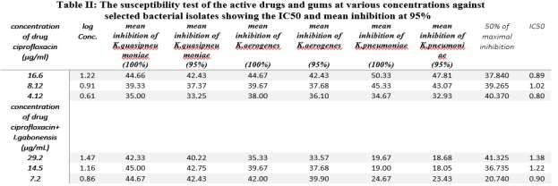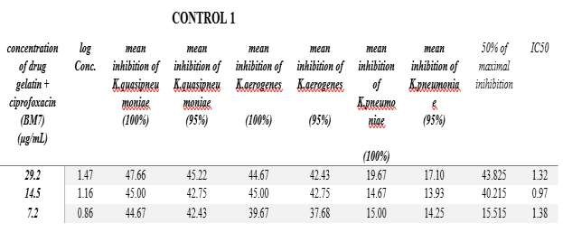
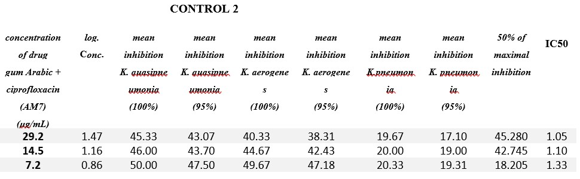

Figure 3.1: FT-IR Spectra of Irvinga Gabonensis Gum
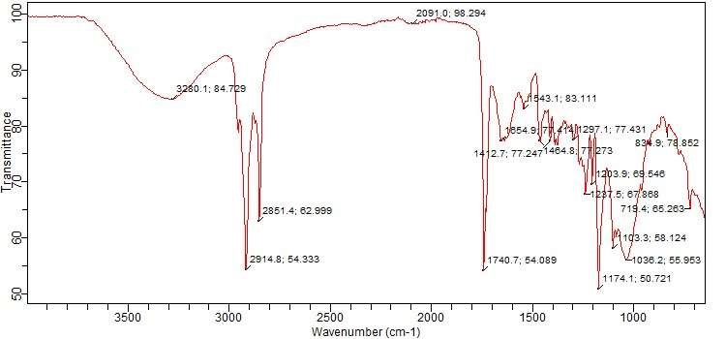

Figure 3.2: FT-IR Spectra of Ciprofloxacin
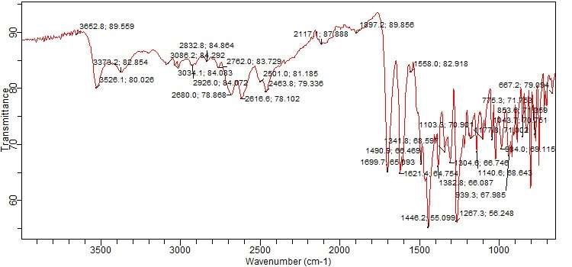
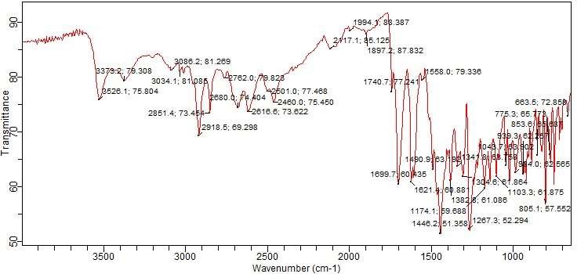

Figure 3.2: FT-IR Spectra of Ciprofloxacin

Figure 3.3: FT-IR Spectra of Ciprofloxacin+ Irvinga Gabonensis Gum Blend
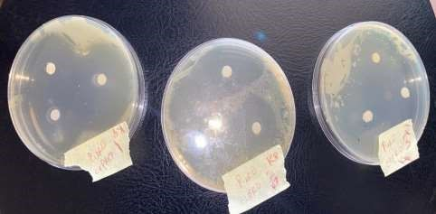
Figure 3.4: shows the plates of the susceptibility test of the various concentration of the active ciprofloxacin inpregnated on the filter paper disc.
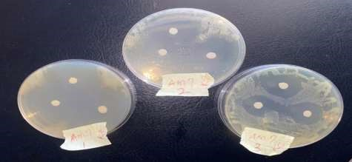
Figure 3.5: shows the plates of the susceptibility test of the various concentration of the active ciprofloxacin and the excipients (AM7), inpregnated on the filter paper disc.
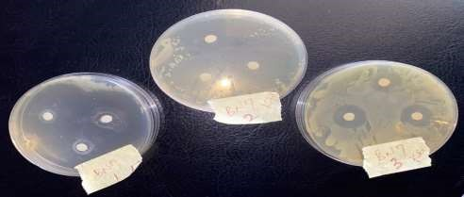
Figure 3.6: shows the plates of the susceptibility test of the various concentration of the active ciprofloxacin and the excipients (BM7) ), inpregnated on the filter paper disc.

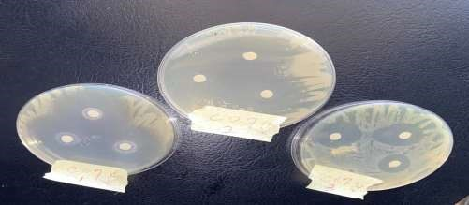
Figure3.7: shows the plates of the susceptibility test of the various concentration of the active ciprofloxacin and the excipients (CO7), ), inpregnated on the filter paper disc.

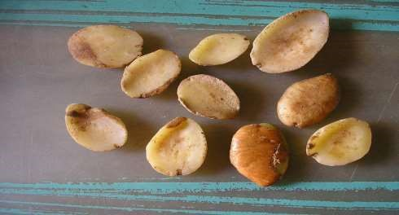
Figure 3.8: shows the plates containing Irvinga gabonensis plant seed

0
10
20
30
40
50
0
0.2
0.4
0.6
0.8
1
1.2
1.4
IC (95%)
Fig 3.9: shows the graph of Log concentrations o f ciprofloxacin against 95% mean inhibition of K. quasipneumoniae

35
36
37
38
39
40
41
42
43
0
0.2
0.4
0.6
0.8
1
1.2
1.4
IC (95%)
Fig 3.10: shows the graph of Log concentrations o f ciprofloxacin against 95% mean inhibition of K.aerogenes

0
10
20
30
40
50
60
0
0.2
0.4
0.6
0.8
1
1.2
1.4
IC (95%)

Fig 3.11: shows the graph of Log concentrations o f ciprofloxacin against 95% mean inhibition of
K.pneumoniae

40
40.5
41
41.5
42
42.5
43
0
0.2
0.4
0.6
0.8
1
1.2
1.4
1.6
IC (95%)
Fig 3.12: shows the graph of Log concentrations of ciprofloxacin+ Irvinga gabonensis against IC95% mean inhibition of K.quasipneumoniae

33
34
35
36
37
38
39
40
41
0
0.2
0.4
0.6
0.8
1
1.2
1.4
1.6
IC (95%)
Fig 3.13: shows the graph of Log concentrations of ciprofloxacin+ Irvinga gabonensis against

IC95% mean inhibition of K.aerogenes

0
5
10
15
20
25
0
0.2
0.4
0.6
0.8
1
1.2
1.4
1.6
IC (95%)
Fig 3.14: shows the graph of Log concentrations of ciprofloxacin+ Irvinga gabonensis against IC95% mean inhibition of K. pneumoniae

42
42.5
43
43.5
44
44.5
45
45.5
0
0.2
0.4
0.6
0.8
1
1.2
1.4
1.6
IC (95%)
Fig 3.15: shows the graph of Log concentrations of ciprofloxacin+ Gelatine gum against IC95% mean inhibition of K. quasipneumoniae

36
38
40
42
44
0
0.2
0.4
0.6
0.8
1
1.2
1.4
1.6
IC (95%)
Fig 3.16: shows the graph of Log concentrations of ciprofloxacin+ Gelatine gum against IC95% mean inhibition of K. aerogenes

0
5
10
15
20
0
0.2
0.4
0.6
0.8
1
1.2
1.4
1.6
IC (95%)
Fig 3.17: shows the graph of Log concentrations of ciprofloxacin+ Gelatine gum against IC95% mean inhibition of K.pneumoniae

42
43
44
45
46
47
48
0
0.2
0.4
0.6
0.8
1
1.2
1.4
1.6
IC (95%)
Fig 3.18: shows the graph of Log concentrations of ciprofloxacin+ Arabic gum against IC95% mean inhibition of K. quasipneumoniae

0
10
20
30
40
50
0
0.2
0.4
0.6
0.8
1
1.2
1.4
1.6
IC (95%)

Fig 3.19: shows the graph of Log concentrations of ciprofloxacin+ Arabic gum against IC95% mean
inhibition of K. aerogenes

16.5
17
17.5
18
18.5
19
19.5
0
0.2
0.4
0.6
0.8
1
1.2
1.4
1.6
IC (95%)
Fig 3.20: shows the graph of Log concentrations of ciprofloxacin+ Arabic gum against IC95% mean inhibition of K.pneumoniae

4.0 Discussion
The medicinal uses of Irvingia spp. are many, but may not easily be assign to individual species or against disease causing agents like Klebsiella species. Though, Irvingia gabonensis is indigenous to the humid forest zone of the Gulf of Guinea, from western Nigeria, east to the Central African Republic, and south to Cabinda (Angola) and the westernmost part of DR Congo according to Atangana,et. al,(2002). It is also planted in parts of the areas like; south-western Nigeria and southern Cameroon, (Atangana,et. al,2002).
From this study, the formulation of the excipients is as shown in Table I, while the analysis in Table II, showed that the pure active ciprofloxacin was seen to be very effective at the concentration of 16.6µg/ml against all the species of Klebsiella isolated from the IUTH. Also, at a reduced concentration of 8.3µg/ml and 4.12µg/ml, the drug was still very effective on all the Klebsiella species tested, with an IC50 of 1.02µg/ml and 0.8µg/ml respectively. Also in Table II, the analysis showed that the active ciprofloxacin + Irvinga gabonenesis gum had a close effect ( IC50 = 1.22µg/mL and 0.90µg/mL), showing that the drug and the excipient are very compactible to each other as seen in the fig, 3.1, 3.2 and 3.3 FT-IR spectra respectively. The active ciprofloxacin + gelatin and the ciprofloxacin + Gum Arabic at the concentration of 14.5µg/ml had no reduced significant effect on the organisms when compare to the active ciprofloxacin active drug at 8.3µg/ml, though at the concentration of 4.12µg/ml of the active ciprofloxacin, it had more effect than the ciprofloxacin + Gum Arabic concentration at 7.2µg/ml. While, the results of the active ciprofloxacin + Gelatin at the concentration of 14.5µg/ml had similar significant effect on the organisms when compare to the active ciprofloxacin active drug at 8.3µg/ml, though at the concentration of 4.12µg/ml of the active ciprofloxacin little difference in its effect were observed based on the zones of inhibition of the ciprofloxacin + Gelatin concentration at 7.2mg/ml. Further analysis showed that the active ciprofloxacin + Irvirga gabonenesis at the concentration of 14.5µg/ml ( 1C50 = 1.22) had no reduced significant effect on the organisms when compare to the active ciprofloxacin active drug at 8.3µg/ml( IC50= 1.02) (Table II ), which reveals that the plant gum did not interact with microbial activities of the ciprofloxacin active drug, though at the concentration of 4.12µg/ml of the active ciprofloxacin(IC50= 0.80) had more effect than the ciprofloxacin + Irvirga gabonenesis concentration at 7.2µg/ml (IC50= 0.9). This may be due to genotypic constituents, mutations or AcrAB efflux system which is one of the principal factor contributing to the different species of the organisms variation in response to the drugs. Analysis showed that significant differences were seen on the isolate K. aerogenes. These findings support the reports of Pakzad, et al.,(2013), Struve and Krogfelt (2004); and Varon and Alangaden (2004), when they reported Klebsiella spp., as harboring, AcrA gene, AcrAB efflux and mutation which could be responsible for their variations in resistance to the drug components studied.

Conclusion
In this study, the microencapsulated ciprofloxacin + Irvinga gabonensis extract were effective against the species of Klebsiella used. The effect of the results showed that ciprofloxacin is a drug of choice in the management and treatment of pneumonia causing organism like Klebsiella spp. Secondly, the effect and the release kinetic of ciprofloxacin was not affected, rather it was very efficacious. From the analysis on the FT-IR spectra for ciprofloxacin active drug and the blend of ciprofloxacin - Irvinga gabonensis gum (fig. 3.1, 3.2,3.3) showed no significant difference as regard the spectrum of activity using the infra-red spectrophotometer, when evaluated using the Jacox 2003 interpretation, mean concentration IC95% and the IC50. This analysis indicates that no chemical interaction was observed based on the FT-IR spectra, when the drug and gum of the plant were blended together and was confirmed in this study by the evaluation of the antimicrobial activity using the IC50.
From the results in this study, investigation revealed that ciprofloxacin is chemically compatible with the Irvinga gabonensis gum extract (excipients), when compared to the usual excipients (gelatin and Arabic gum) normally used in this pharmaceutical dosage design. Though, the result of the antimicrobial susceptibility test found in this study were not in line with the study carried out by Pakzad, et al, (2013) using ciprofloxacin, as the drug ciprofloxacin in this study, showed clear zone of inhibition as shown in fig 3.4, 3.5, 3.6 and 3.7, irrespective of the blend with other excipients.
Disclosure of conflict of interest
All authors declared that there is no conflict of interest.

Acknowledgement
We acknowledge every one that contributed to the success of this research, especially Igbinedion University Teaching Hospital, the South African Biotech Laboratories and their Staff for their unending support during the microbial isolation and DNA analysis of this research study. We appreciate Dizpharm Pharmaceutical company, Vardhaman Health care, Ahmedabad India for providing us the active drug.
Funding
This research did not receive any grant from funding agencies, Public or commercial

References
Atangana AR, Tchoundjeu Z, Fondoun JM, Asaah, E, Ndoumbe M & Leakey RRB, (2001). Domestication of Irvingia gabonensis: 1. Phenotypic variation in fruits and kernels in two populations from Cameroon. Agroforestry Systems. 53: 55–64.
Atangana AR, Ukafor V, Anegbeh P, Asaah E, Tchoundjeu E, Fondoun JM, et. al (2002). Domestication of Irvingia gabonensis and the selection of multiple traits for potential cultivars from Cameroon and Nigeria. Agroforestry Systems 55(3): 221–229.
Bamidele OP, Ojedokun OS, and Fasogbon OB (2015) Physico-chemical properties of instant ogbono (Irvingia gabonensis) mix powder.doi.org/10.1002/fsn3.220
Bryan C., Nicholson AG (2011) Infectious disease. Pathology of the Lungs (Third Edition).
Cheesbrough M. (2002) District Laboratory Practice in Tropical countries. Part 2: Cambridge University Press, Cambridge UK. p 136-142.
CLSI (2011) Clinical and Laboratory Standards Institute. Performance standards for Antimicrobial Susceptibility Testing, 21st informational supplement. Performance for antimicrobial disc testing,9th Ed. CLSI.
Jacox ME (2003). Vibrational and electronic energy levels of polyatomic transient molecules.supplet. B. Journal of Physical and Chemical Reference Data 32:1. doi.org/10.1063/1.1497629.
Jyothi SS, Seethadev AI, Suria PK, Muthuprasanna P and Pavitra P (2012) Microencapsulation: A review. International Journal of Pharma and Bio Sciences. Vol 3/Issue.
Jukes TH and Cantor CR (1969) Evolution of Protein Molecules. In: Munro, H.N., Ed., Mammalian Protein Metabolism, Academic Press, New York, 21-132. http://dx.doi.org/10.1016/B978-1-4832-3211-9.50009-7.
Lowe AJ, Gillies ACM, Wilson J. and Dawson IK (2000). Conservation genetics of bush mango from central/west Africa, implications from RAPD analysis. Molecular Ecology 9: 831–841.
Malele1 RS., Mwambete, K.D., and Hassanali, L.Q., (2014) Antibacterial Effects of Nine Brands of Ciprofloxacin Tablets Available in Dar es Salaam. East and Central African Journal of Pharmaceutical Sciences. Vol. 17. 10-17.
Nnamani ND. and Kashimawo AJ (2020). Design and evaluation of drug release kinetics of theophylline from coprocessed colocasia esculenta gum. Nigerian Journal of Pharmaceutical and Applied Science Research,9(1):55-62.
Ogaji IJ, Nan A and Hang SN. (2012). A novel extraction method and some physicochemical properties of extractives of Irvinga gabonensis seeds. Journal of Young Pharmacist, 4(2):66-72.
Onyenwe NE., Adeleke, O.E., Mbata TI (2011) Comparative analysis on the curing effects of Acridine orange
(mutagene) on B-Lactamase producing Staphylococcus aureus from bovine and human. African Journal of Microbiology Research. Vol.5(25), Academic journals 5(25),pp. 4278-4290. doi.org/10.5897/AJMR11.023.
Pakzad I, Karin MZ, Taherikalani M, Boustanshenas M., Lari AR.(2013) Contributions of AcrAB efflux pump to ciprofloxacin resistance Klebsiella pneumonia isolated from burn patients. GMS Hyg infect Control. 8:(2); Doc.15.
SeemanchalaRath BKG, NripendraNath B, (2012) Microencapsulation of a mixture of herbal extracts by non-solvent addition method. American Journal of Pharmtech Research. 2(4): 572-581.
Struve C, Krogfelt KA. (2004) Pathogenic potential of environmental Klebsiella pneumoniae isolates. Environ Microbiol. 6(6):584–590.
Varon, N.F., Alangaden, G.J., (2004) Emerging trends in infections among renal transplant recipients. Expert Rev Anti Infect.Ther. 2(1):95–109.
Varshney A, Ansari Y, Zaidi N, Ahmad E, Badr G, Alam P, Khan RH:(2014) Analysis of binding interaction between antibacterial ciprofloxacin and human serum albumin by spectroscopic techniques. Cell Biochem Biophys. ;70(1):93-101.
Zhang GF, Liu X, Zhang S, Pan B, Liu ML (2018): Ciprofloxacin derivatives and their antibacterial activities. Eur J Med Chem. 25; 146:599-612.

